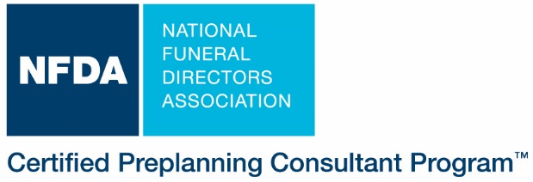
NFDA Staff Use ONLY

Renewal Approved by: _________________ Date: ________________

NFDA │13625 Bishop’s Drive │ Brookfield, WI 53005 │ 800-228-6332 │ email nfda@nfda.org

Application for CPC Renewal

Entire renewal application must be completed for processing. Please type or print.
Name (+ CFSP if applicable)
As name should appear on certificate
Position Title
Firm Name
Firm Address
Firm City, State, Zip/Postal Code |  |  |  |  |  |  | Country
FD License Number/s and State/s |  |  |  |  | CFSP # if applicable |  | Firm Phone
Insurance License Number and State/s |  |  |  |  |  |  | Fax
Email
Credit Card Number: |  |  |  |  | Payment by Check Number:
AM EX MasterCard VISA Discover |  |  |  |  | Total Fee Submitted: $
Credit Card Expiration Date: |  |  | CVV |  | Name on Credit Card:
Signature
Certification renewable every 4 years: 6 hours per year of educational and approved related activities to equal the 24 hours for renewal.

The Applicant warrants to NFDA as follows and acknowledges that NFDA is relying upon the truth and accuracy of each such warranty.

CPC. I remain actively involved in direct advance selling of funeral goods and services to the public for complete funerals as permitted by state or provincial law. | Associate CPC. I do not sell funerals to the public; I am actively involved in the funeral preplanning field as supervisor, manager, instructor, or other type of preplanning-related position.

1. Renewal Eligibility Verification. By immediate supervisor or by applicant if applicant is firm owner.
As immediate supervisor of the applicant named above, I verify for purposes of the CPC certification program that applicant is a current employee of this firm and attest to the truth and accuracy of items a-d below.
Note If you as the applicant named above are the firm owner, complete a-d below, sign, and then go directly to Section 3 below.
- Applicant current title:
- Applicant meets statutory criteria to sell preneed funeral goods and services to public. Yes No
- Supervisor’s name and title:
- Name of firm:
Supervisor Signature: Date:
OR Applicant/Owner Signature: Date:

2. Type of Business. Check all boxes that describe the firm where you are employed.

 | Independent funeral home |  | Owns/operates cemetery |  |  | Supplier of insurance product
 | Independent cooperative funeral home |  | Owns/operates crematory |  |  | Supplier of trust product
 | Publicly-traded corporate funeral home |  | Other (specify):

CPC Renewal 2020 Page 1 of 3

NFDA Certified Preplanning Consultant RENEWAL Application Page 2 of 3

3. Personal Data. Provide non-business address information.
Home Address
City | State | Zip/Postal Code |  |  |  | Country
Home Phone |  | Home FAX
Home Email

4. Brief description of current preplanning responsibilities.

5. What is the value of the CPC designation to you?

6. CPC Code of Ethics. To renew, you are required to reaffirm your pledge to comply with the CPC Code of Ethics.
Read and sign below to signify intent.

Service to Families
- I will treat the information shared with me during the preplanning interview with confidentiality and integrity.
- I will offer my services to all without regard to religion, race, color, national origin, sex, sexual orientation or disability.
- I will at all times maintain the standards and obligations of the funeral home that I represent.
- I will provide my client with detailed price lists of services and merchandise before he or she selects services or merchandise, and at the conclusion of the funeral arrangement conference will provide a written statement listing all of the services and merchandise that have been purchased.
- I will properly account for and remit any monies, documents or personal property belonging to others that come into my possession.
- I will answer any questions the client may have pertaining to the preneed agreement, including any guarantees and representations, and will attempt to resolve any problems efficiently and fairly and with due consideration given to the views and concerns of the client.
Obligations to the Public
- I will make no representation, written or oral, that may be false or misleading or that is likely to defraud or deceive the public.
- I will abide by the provisions of the NFDA CPC Statement of Use regarding the appropriate and responsible use of the CPC designation.
- I will continue my professional education in this field.
- I further pledge to conduct myself at all times in a manner that deserves the public trust.

Obligations to the Government
- I will continue to hold all necessary licenses to engage in providing preneed services and products in the state or states in which I practice.
- I will maintain my accountability to the client by complying with all applicable state and federal regulations and standards governing funeral preplanning, trust and insurance funding for funerals, and consumer protection.

7. RENEWAL Submission Instructions

I have read and pledge to comply with the CPC Code of Ethics above and the CPC Statement of Use and warrant that NFDA can rely upon the truth and accuracy of all information submitted on or attached to this CPC Application for Renewal.

Applicant Signature Date

Mail, scan/email or FAX completed application + fee (US $ on US bank or credit card information if emailing or faxing) to:

NFDA CPC Program, 13625 Bishop’s Drive, Brookfield, WI 53005-6607, U.S. Fax 1-262-789-6977; Email nfda@nfda.org.

Please retain a copy of the renewal application.
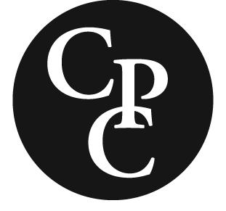
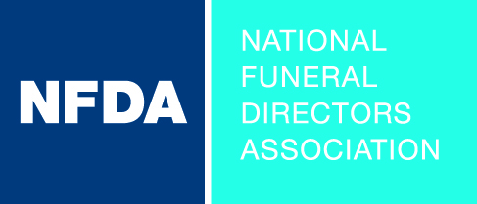
Certified Preplanning Consultant
CE & Professional Development Activity Summary

You can key in your data on this form, then print, sign and fax or mail it to NFDA. Retain a printed copy or save a copy for your records.

Today’s Date: |  | Original Certification Month & Year:

Name:

Directions: 24 total combined hours of CE and professional development activities over 4 years required. Refer to Renewal Policy for guidelines. Fill in below and attach documents verifying attendance, completion or performance and contact hours.

Title of CE Program or Professional Development Activity |  | Location | Provider | Date | Hours
 | (Example) “Embalming Risk Management” online learning course | Online | NFDA | November 2018 | 3
 | (Example) Illinois State Association Convention | Springfield, IL | IFDA | June 2019 | 8
1
2
3
4
5
6
7
8
9
10
11
12
13
14
15
16
17
18
19
20
21
22
23
24
25
 | Total Hours

Renewal Candidate Signature Date

